SQL PROJECT

create database BooksDB;

use BooksDB;

create table Books(Book_title varchar(20),author_name varchar(20),genre

varchar(20),publication_year int,price int);

insert into Books values('Dream','Sam','Fantasy',2003,300);

insert into Books values('The Ghost','Alan','Horror',2000,700);

insert into Books values('Suspect','Robert','Thriller',2008,400);

insert into Books values('Hands Together','Wilson','Love',2018,1500);

insert into Books values('Adventure','Mary','Action',2013,1000);

select*from Books;

select*from Books where Book_title='The Ghost';

update Books set price=500 where Book_title='Dream';

delete from Books where Book_title='Dream';

select AVG(price) from Books;

CREATE TABLE authors (author_id INT PRIMARY KEY,author_name VARCHAR(100) NOT NULL);

ALTER TABLE Books ADD COLUMN author_id INT;

ALTER TABLE Books ADD CONSTRAINT FOREIGN KEY (author_id)

REFERENCES authors(author_id);

INSERT INTO authors(author_id, author_name)VALUES(100, 'Sam'),(101, 'Alan'),(102, 'Robert'),(103, 'Wilson'),(104, 'Mary');

select books.Book_title,authors.author_id from books,authors where Books.author_name=authors.author_name;

1.Retrieve all the books from the database.

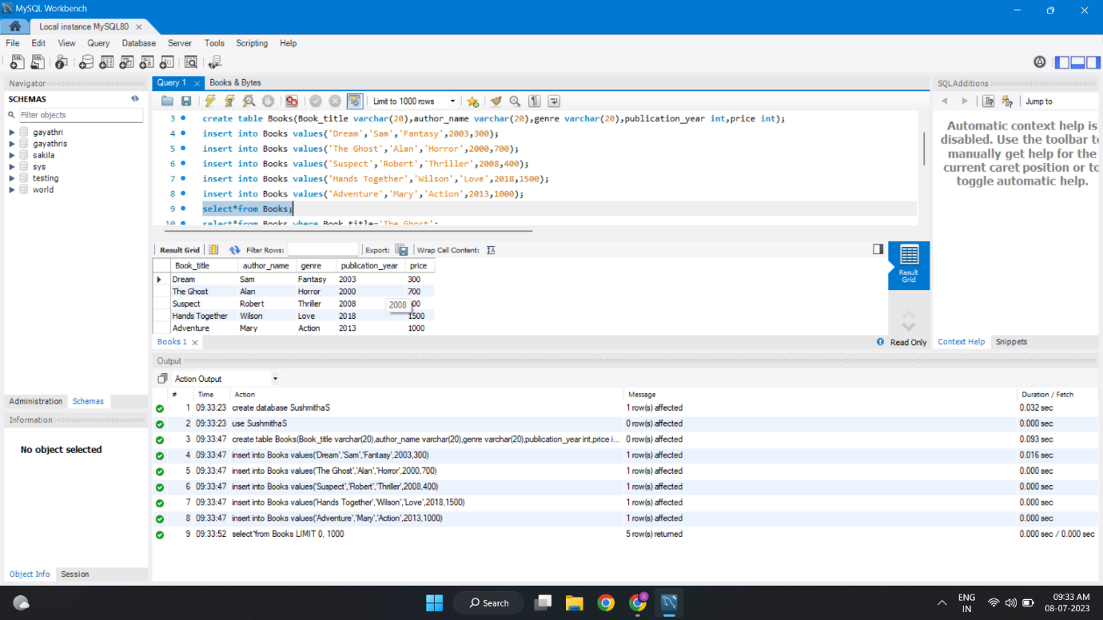

2.Retrieve the details of a book based on its title:

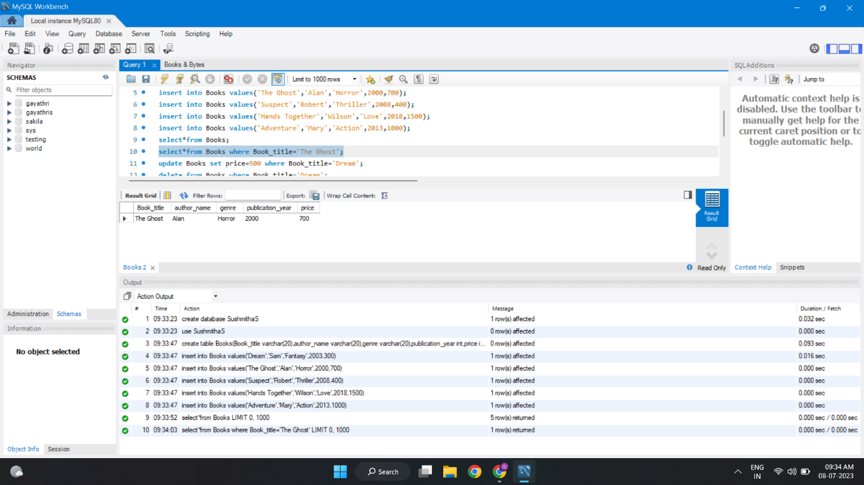

3.Update the price of a book:

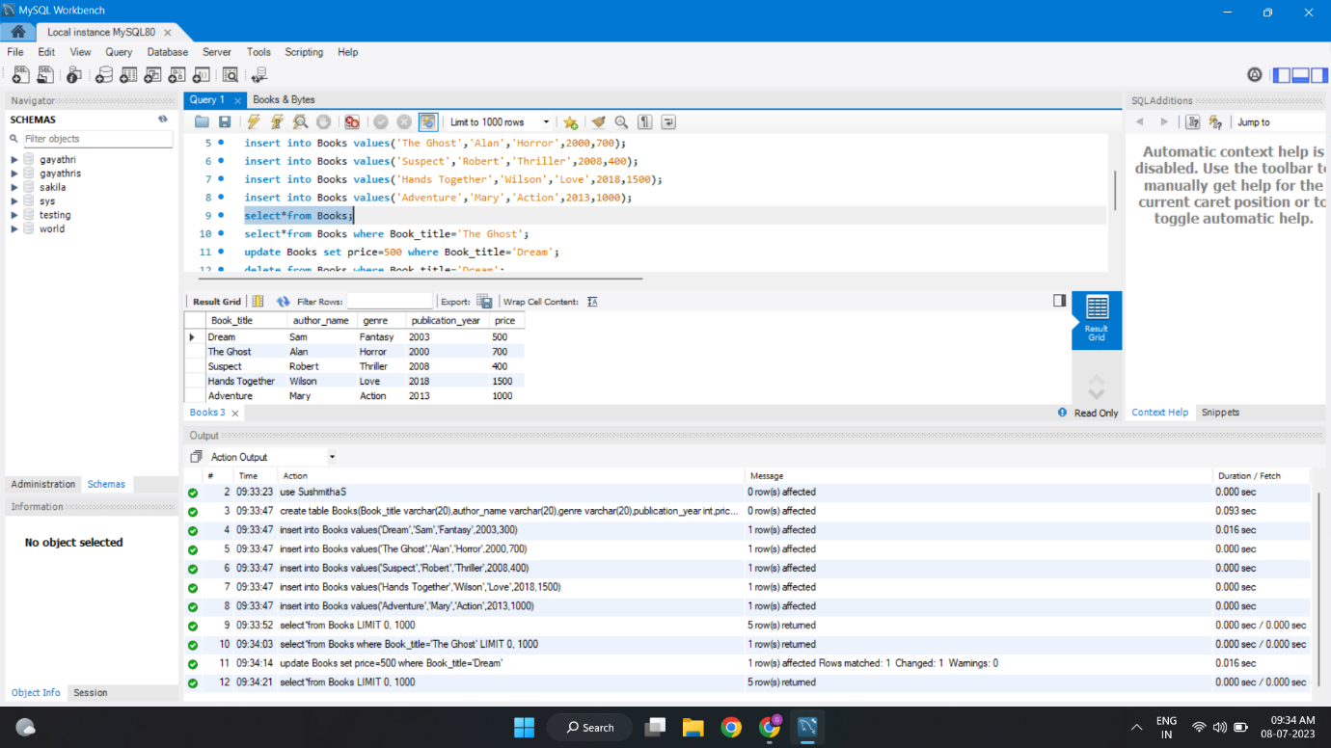

4.Delete a book from the database based on its title:

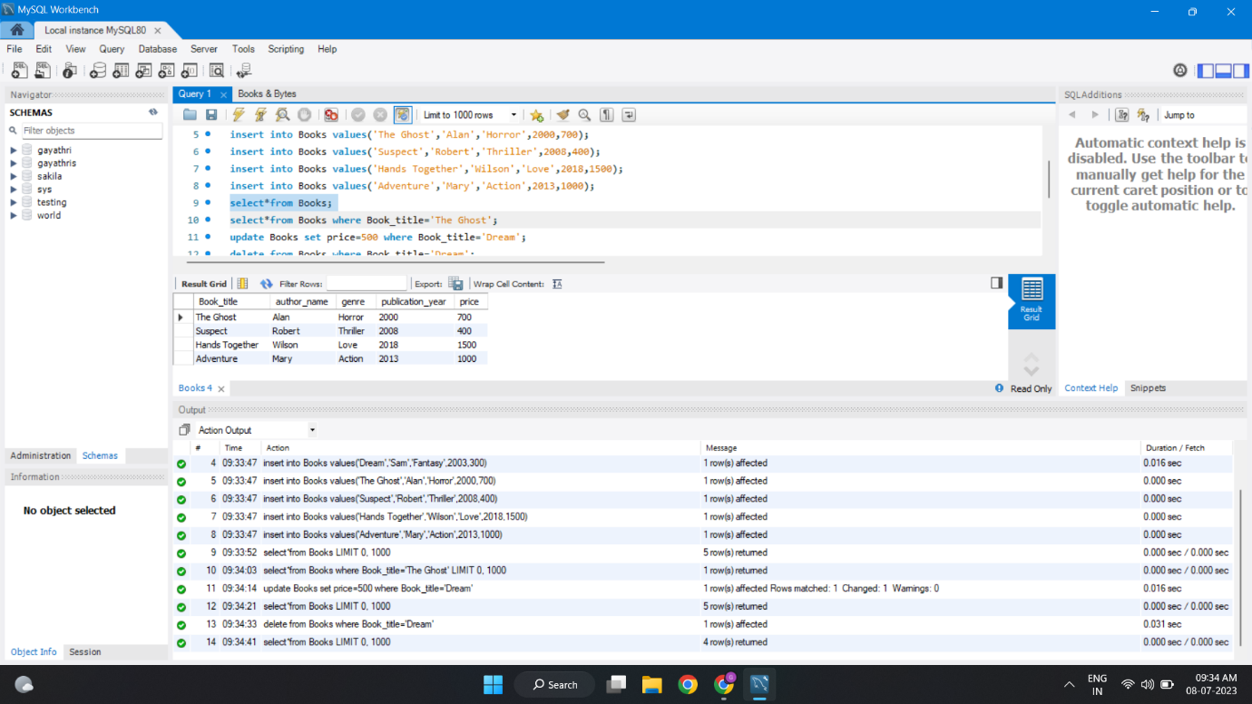

5.Query to Calculate and display the average price of all the books in the database:

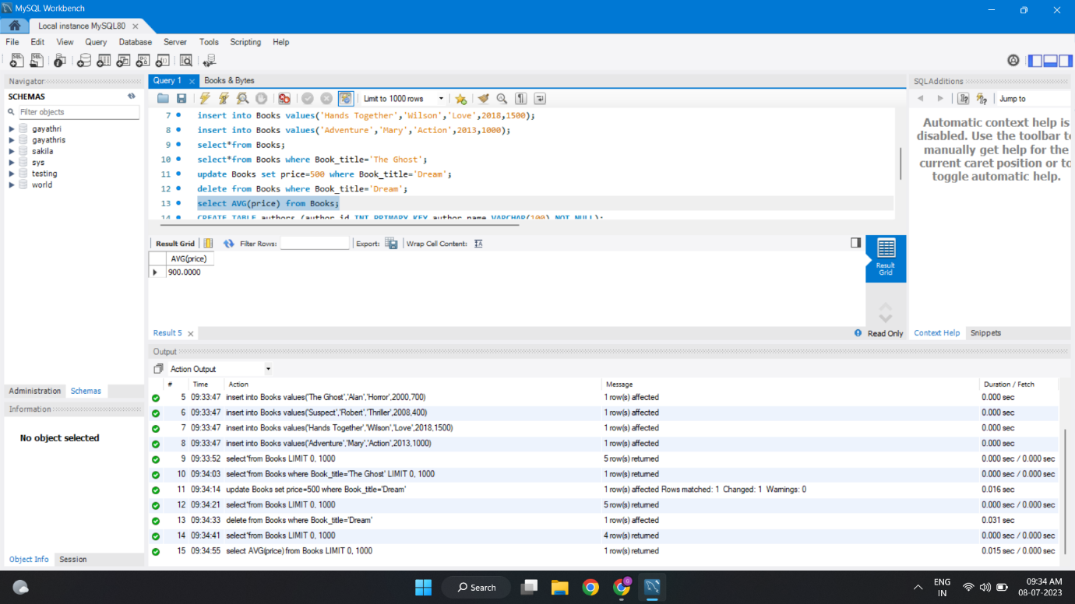

6. Query to retrieve books along with their respective authors:

